PROJECT REPORT***(EDUCONNECT LEARNING CENTER)***

# **1.INTRODUCTION**

1.1 OVERVIEW A BRIEF DESCRIPTION ABOUT YOUR PROJECT.

1.2 PURPOSE THE USE OF THIS PROJECT.WHAT CAN BE ACHIEVED USING THIS.

# **2.PROBLEM DEFINITION AND DESIGN THINKING**

2.1 EMPATHY MAP PASTE THE EMPATHY MAP .

2.2 IDEATION AND BRAINSTORMING MAP PASTE THE IDEATION AND BRAINSTORMING MAP.

# **3.RESULT**

FINAL FINDINGS (OUTPUT) OF THE PROJECT ALONG WITH SCREENSHOTS.

# **4.ADVANTAGES AND DISADVANTAGES**

LIST OF ADVANTAGES AND DISADVANTAGES FOR THE PROPOSED SOLUTION.

# **5.APPLICATIONS**

THE AREAS WHERE THIS SOLUTION CAN BE APPLIED.

# **6.CONCLUSION**

CONCLUSION SUMMARIZING THE ENTIRE WORK AND FINDINGS.

# **1.INTRODUCTION**

**1.1 OVERVIEW A BRIEF DESCRIPTION ABOUT YOUR PEOJECT**

**Distance learning experiments have been launched since 2010 in several Moroccan universities as part of an experimental approach.** **e-learning platforms for teaching and learning, their functional architectures, as well as the types of e-learning devices that can be created from these online learning platforms.**

**In today's rapidly evolving job market, continuous learning and upskilling have become paramount for professional growth and competitiveness [2]. Our Learning center offers a wide array of courses and certifications that enable individuals to acquire new skills or upgrade existing ones. Professionals can engage in online training programs, webinars, and virtual conferences to stay abreast of the latest industry trends and developments. The convenience and accessibility of eLearning make it an ideal platform for lifelong learning, enabling individuals to adapt to changing job requirements and maintain their competitiveness in their respective fields.**

**In our rapidly changing and interconnected world, technology has ushered in a new era of living, working, and learning. The emergence of eLearning stands as one of the most impactful advancements in the field of education. With the widespread availability of the internet and digital devices, eLearning has transformed the way knowledge is accessed, opening doors to learners of all backgrounds and ages. This article delves into the significance of eLearning and its role in shaping the future of education.**

**Traditional education often comes with a hefty price tag, encompassing tuition fees, textbooks, transportation, and accommodation expenses. A significance of eLearning is that it offers a cost-effective alternative. Online courses and educational platforms tend to be more affordable compared to traditional institutions. Moreover, learners save money on commuting expenses and can access digital resources that are often available free of charge. This affordability factor promotes educational accessibility, bridging the gap for individuals from diverse socioeconomic backgrounds and fostering equal opportunities for all.**

**1.2. PURPOSE OF THE USE OF THIS PROJECT.WHAT CAN BE ACHIEVED USING THIS.**

**If you have been assigned the complicated task of planning your learning center programme and don’t know where to start,you are in the right place. Whether you are new to teaching , are looking for some new ideas or need assistance from an teacher of a learning center.**

**E-Learning speeds up the process of learners who got at a quicker place saving time and resources for the ultimate in efficiency. E-Learning can also allow learners to test out of materials, they have already learned also saving time.**

**These are the achievements of Educonnect Learning Center**

### **Greater Access: Benefits for Students Beyond Boundaries**

### **Resource Scalability: Save Time & Money**

### **Better Results: Benefits of E-learning in Information Retention**

### **Improved Pace: Quick & Effective Learning Anytime**

### **Cost-Effectiveness: Save Money on E- Learning vs Traditional Learning**

### **Quick Lesson Delivery: Dynamic and Quick Learning Process**

# **2. PROBLEM DEFINITION AND DESIGN THINKING**

# **2.1 EMPATHY MAP SCREENS**

# 

## **2.2 IDEATION AND BRAINSTORMING SCREENSHOT**

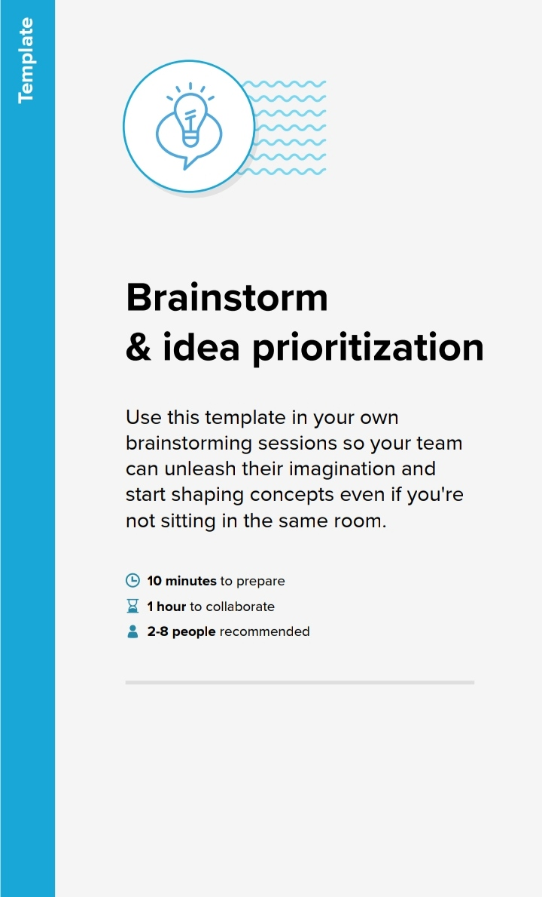

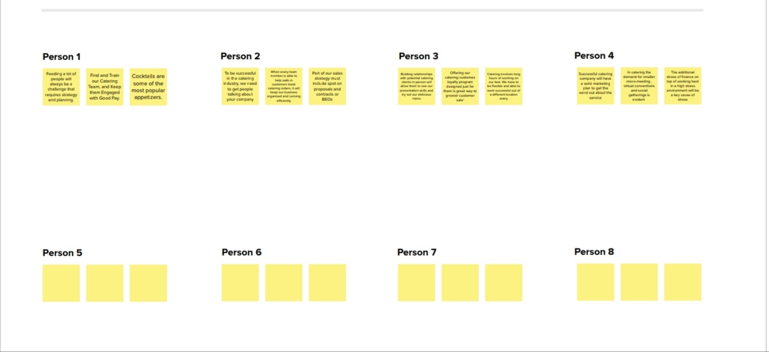

# **3.RESULT**

**Final findings (output) of the project along with screenshots**

**GST REPORTS:**

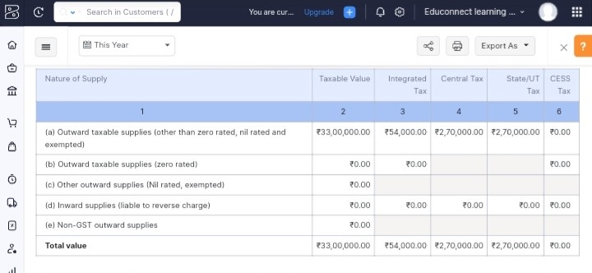

**SALE INVOICE:**

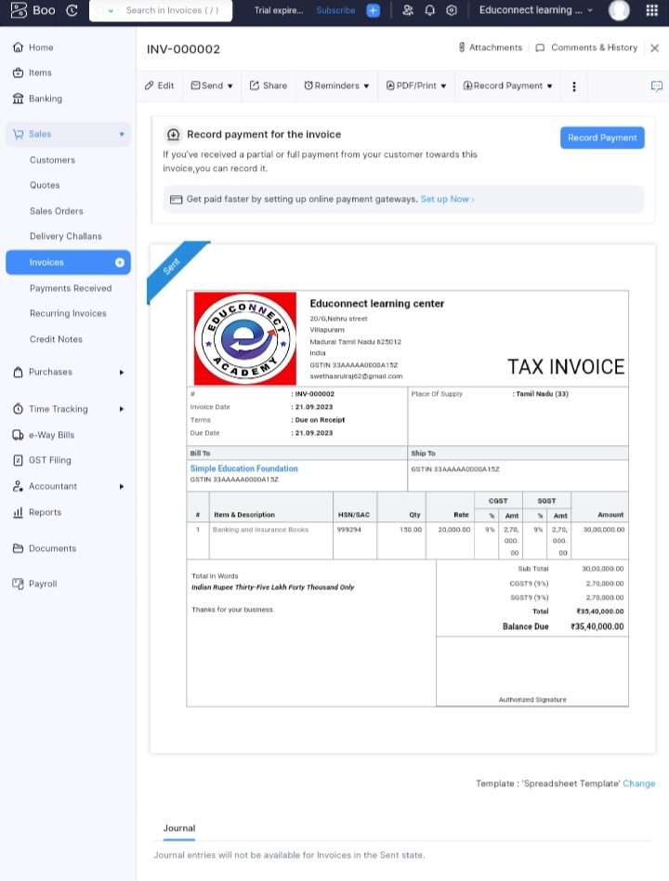

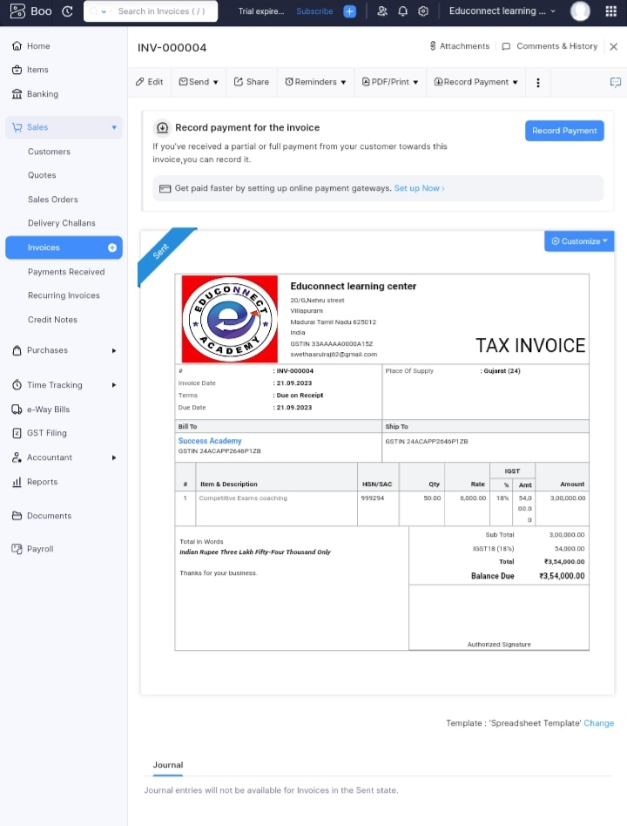

**PURCHASE BILLS:**

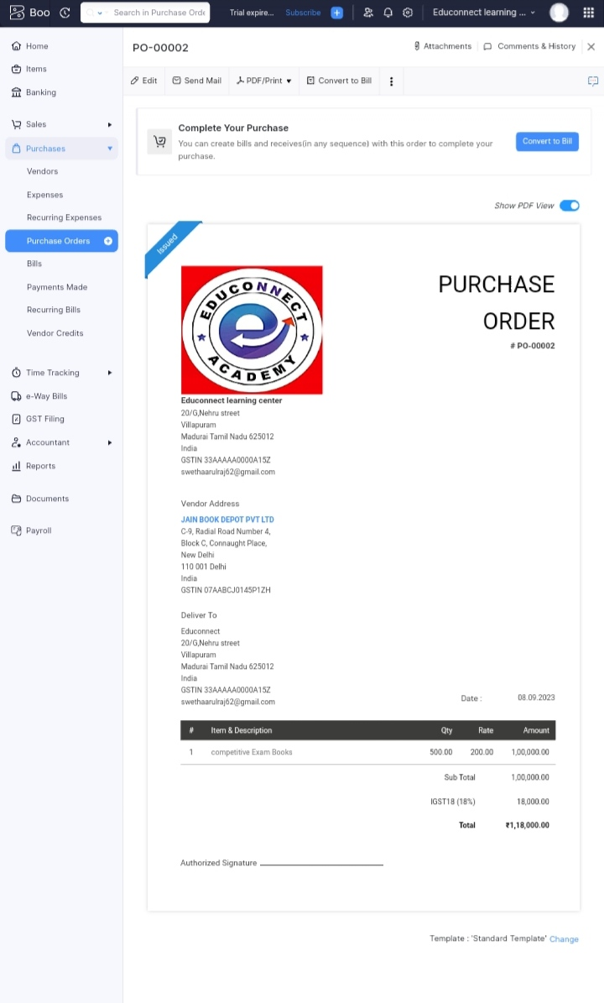



**VENDORS:**

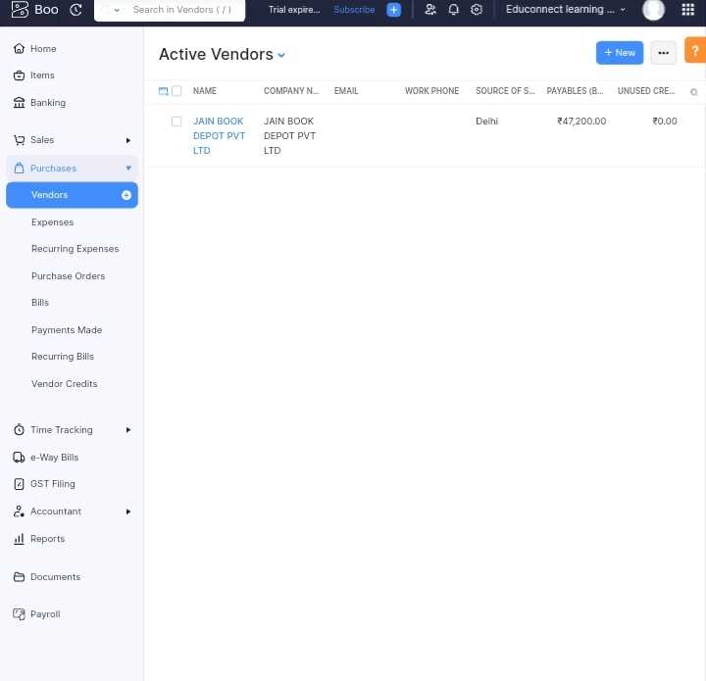

**CUSTOMERS:**

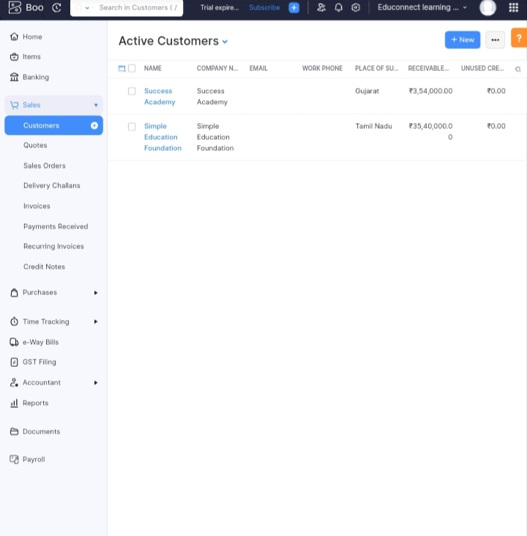

**JOURNAL**

**:**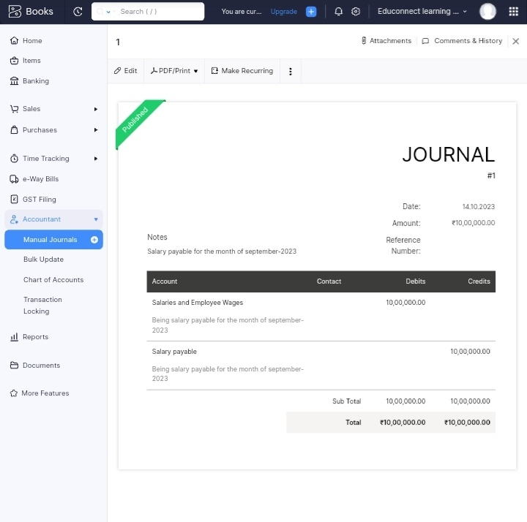

**BANKING:**

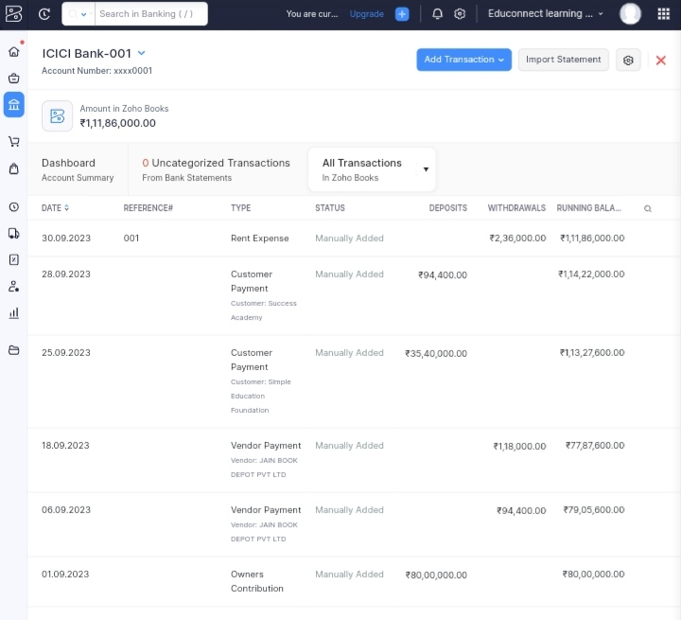

**ADVANTAGES AND DISADVANTAGES OF LEARNING CENTER:**

**ADVANTAGES OF LEARNING CENTER**

**1. Efficiency**

Online learning offers teachers an efficient way to deliver lessons to students. Online learning has a number of tools such as videos, PDFs, podcasts, and teachers can use all these tools as part of their lesson plans. By extending the lesson plan beyond traditional textbooks to include online resources, teachers are able to become more efficient educators.

**2. Accessibility Of Time And Place**

Another advantage of online education is that it allows students to attend classes from any location of their choice. It also allows schools to reach out to a more extensive network of students, instead of being restricted by geographical boundaries. Additionally, online lectures can be recorded, archived, and shared for future reference. This allows students to access the learning material at a time of their comfort.

Thus, online learning offers students the accessibility of time and place in education.

**3. Affordability**

Another advantage of online learning is reduced financial costs. Online education is far more affordable as compared to physical learning. This is because online learning eliminates the cost points of student transportation, student meals, and most importantly, real estate. Additionally, all the course or study materials are available online, thus creating a paperless learning environment which is more affordable, while also being beneficial to the environment.

**4. Improved Student Attendance**

Since online classes can be taken from home or location of choice, there are fewer chances of students missing out on lessons.

**5. Suits A Variety Of Learning Styles**

Every student has a different learning journey and a different learning style. Some students are visual learners, while some students prefer to learn through audio. Similarly, some students thrive in the classroom, and other students are solo learners who get distracted by large groups.

The online learning system, with its range of options and resources, can be personalized in many ways. It is the best way to create a perfect learning environment suited to the needs of each student.

**DISADVANTAGES OF LEARNING CENTER**

**1. Inability To Focus On Screens**

For many students, one of the biggest challenges of online learning is the struggle with focusing on the screen for long periods of time. With online learning, there is also a greater chance for students to be easily distracted by social media or other sites. Therefore, it is imperative for the teachers to keep their online classes crisp, engaging, and interactive to help students stay focused on the lesson.

**2. Technology Issues**

Another key challenge of online classes is internet connectivity. While internet penetration has grown in leaps and bounds over the past few years, in smaller cities and towns, a consistent connection with decent speed is a problem. Without a consistent internet connection for students or teachers, there can be a lack of continuity in learning for the child. This is detrimental to the education process.

**3. Sense Of Isolation**

Students can learn a lot from being in the company of their peers. However, in an online class, there are minimal physical interactions between students and teachers. This often results in a sense of isolation for the students. In this situation, it is imperative that the school allow for other forms of communication between the students, peers, and teachers. This can include online messages, emails and video conferencing that will allow for face-to-face interaction and reduce the sense of isolation.

**4. Teacher Training**

Online learning requires teachers to have a basic understanding of using digital forms of learning. However, this is not the case always. Very often, teachers have a very basic understanding of technology. Sometimes, they don’t even have the necessary resources and tools to conducts online classes.

To combat this, it is important for schools to invest in training teachers with the latest technology updates so that they can conduct their online classes seamlessly.

**5. Manage Screen Time**

Many parents are concerned about the health hazards of having their children spend so many hours staring at a screen. This increase in screen time is one of the biggest concerns and disadvantages of online learning. Sometimes students also develop bad posture and other physical problems due to staying hunched in front of a screen.

**APPLICATIONS:**

**The areas where this solution can be applied**

* E-learning requires self-discipline and self-motivation in order to be successful. Because the learner is fully in charge of their own progress, they will literally get out of the learning what they put in.
* It misses the face-to-face aspect of learning, and for some people, having that face-to-face contact may be a huge motivator to them, which e-learning mostly lacks. Even if a learner has access to a real-life trainer online, the social aspect is missing, which may make e-learning not a suitable option for everybody.
* It is technology dependent and learners need access to appropriate hardware and software to benefit fully. Internet connections and bandwidth are particular problems.
* It doesn’t provide practical training. Whilst e-learning can provide the theory aspect of training, it does not provide practical training and practice, which may be needed in some subjects to ensure competency. This would be an example of when blended learning is required, which allows you to use e-learning alongside traditional face-to-face practical training and application.
* Whilst e-learning often comprises an assessment element or elements, these are not under strict examination conditions; this means that online assessment elements may not be suitable for some qualifications.

**CONCLUSION:**

Conclusion summarizing the entire work and findings.

**Profit and loss:**

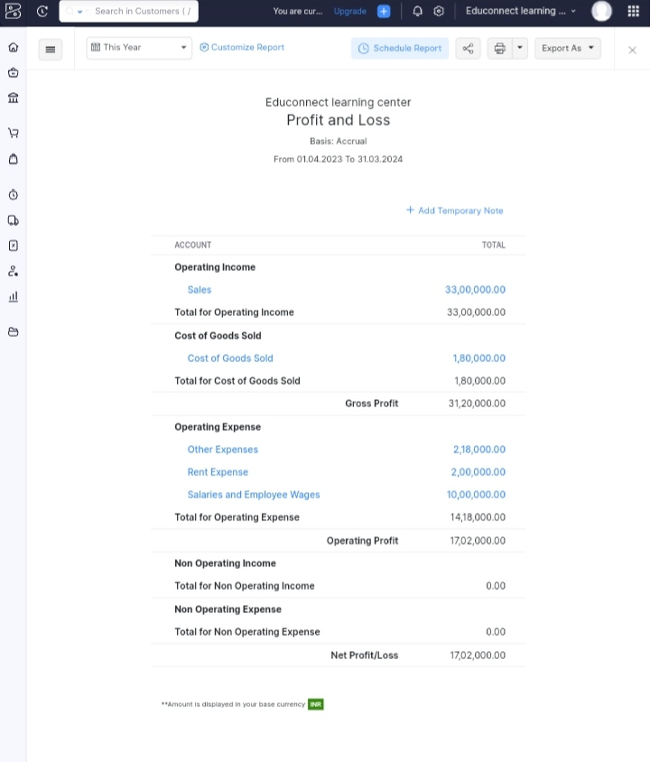

**BALANCE SHEET:**

